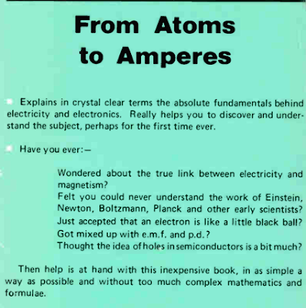
From Atoms to Amperes by F.A. Wilson.
A really great book if you want to dig into the theory (without going off the deep end!)
Free here:
https://worldradiohistory.com/UK/Bernards-And-Babani/Bernards/BP254-From-Atoms-To-Amperes-Wilson-1989.pdf

